1 Introduction 1
2 Scope and field of application 1
3 Definitions and Abbreviations 1
3.1 Examples 2
3.1.1 Examples / inspiration 2
3.1.2 EmonCMS ( Clean dashboard, advanced timeseries dataviewer ) 2
3.1.3 Dashboard example Northstar: 4
3.1.4 Configurable dashboard example iDean: 8
3.1.5 Inala ( old style UI, good features/information ) 10
3.1.6 NetAct example of internal System Monitoring 12
3.1.7 Vertiv / Emmerson 13
3.1.8 Huawei OLAP reporting 13
3.1.9 13
3.1.10 Example of extended Dashboard item in existing MSM (needs correct colors 😊) 14

DOCUMENT CHANGE RECORD

Rev. | Date | Author | Nature of revision
1.0 | 09.11.2017 | Tonny Mastad | Initial Revision
1.1 | 24.01.2018 | Tonny Mastad | Added look and feel and scalability

Introduction
This document gives some inspiration from other similar products.

Scope and field of application

Definitions and Abbreviations
MSM - Multisite Monitor
REST - Representational State Transfer
JSON - Java Script Object Notation
Microservice - Implementation approach to build flexible, independently deployable software systems.
UI - User Interface
UX - User eXperience

Examples

Examples / inspiration
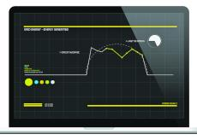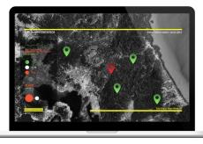
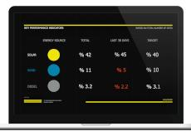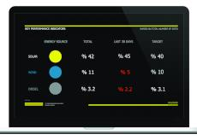

EmonCMS ( Clean dashboard, advanced timeseries dataviewer )
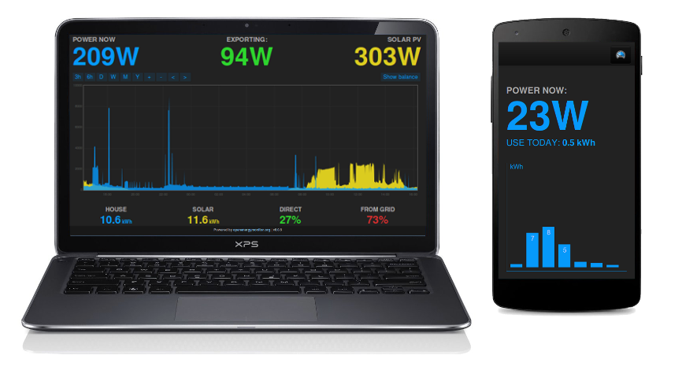

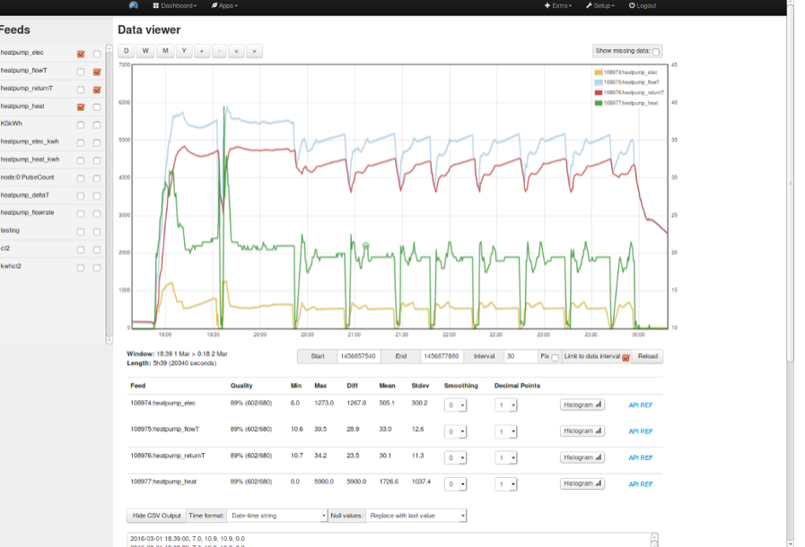
https://github.com/emoncms/graph
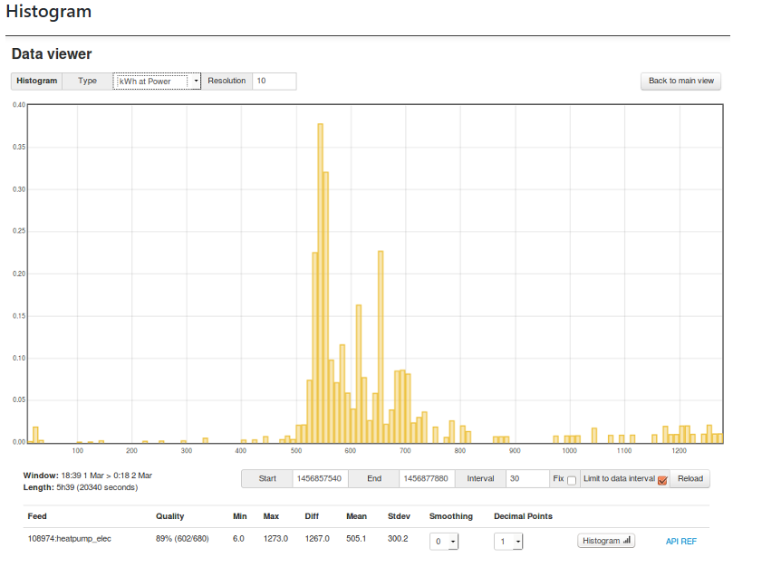
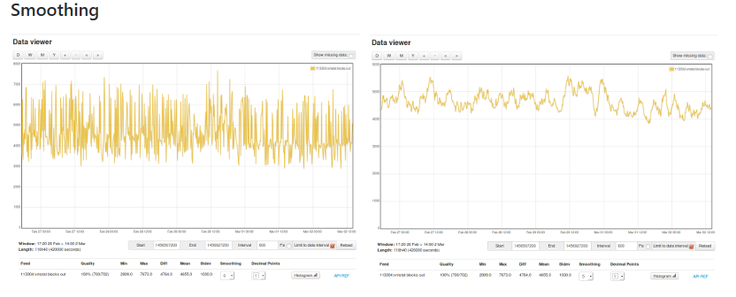

Dashboard example Northstar:

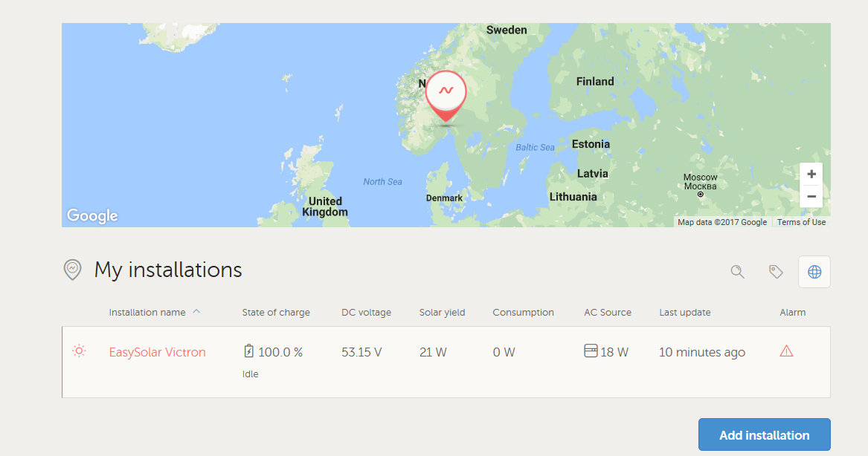

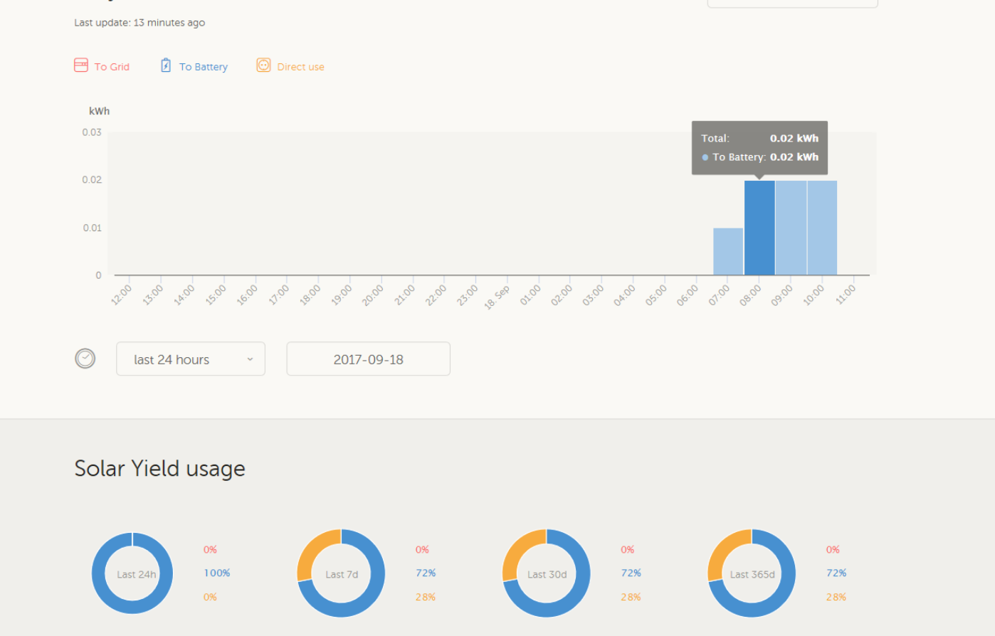

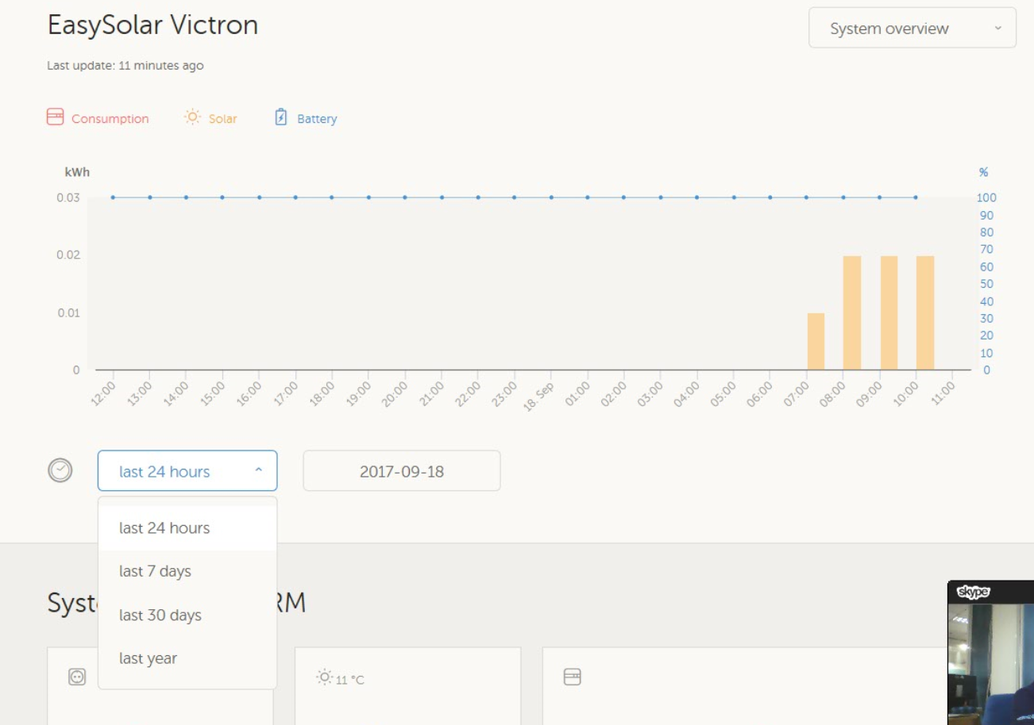

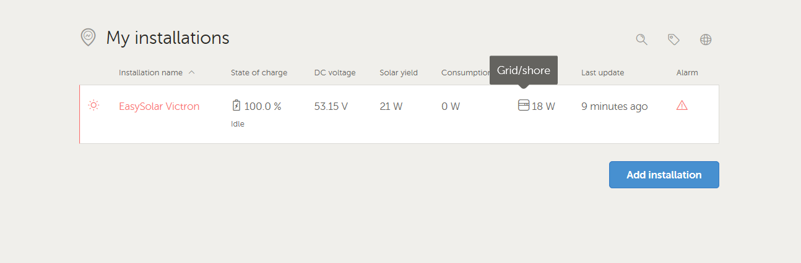

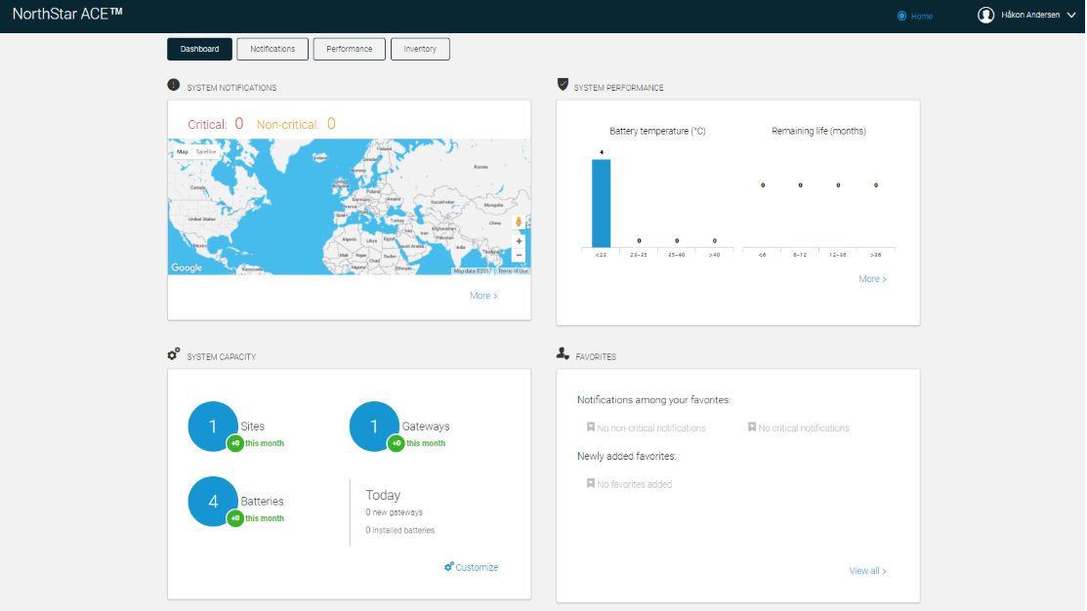

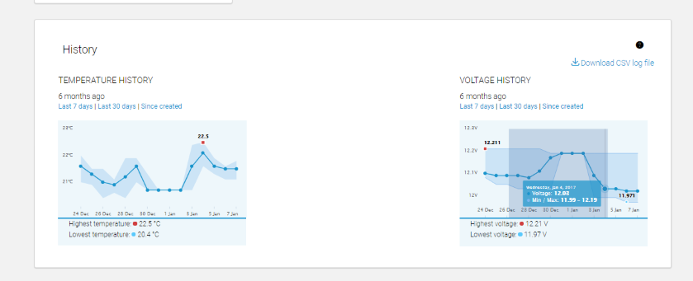
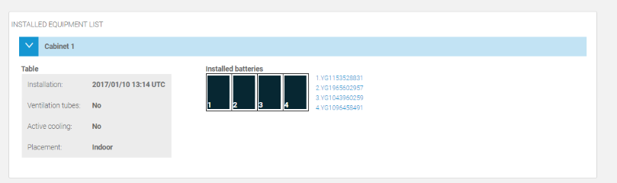

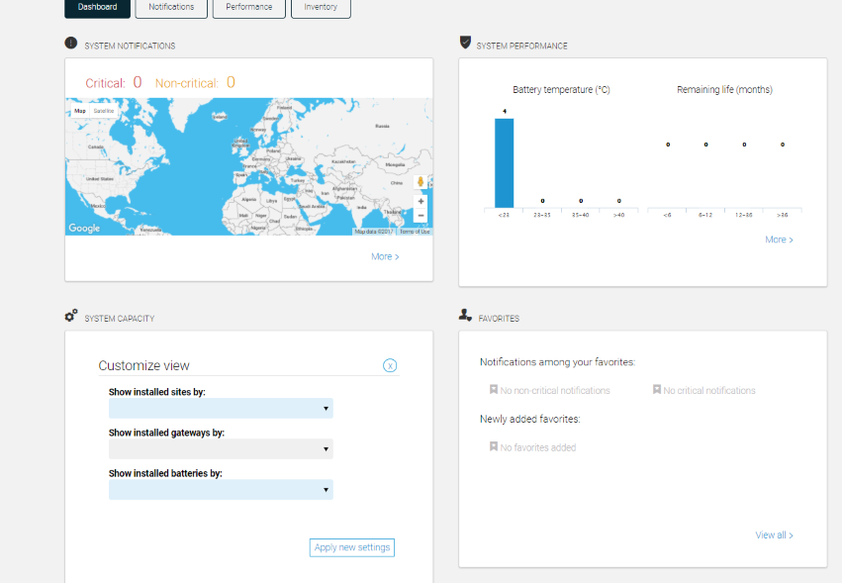

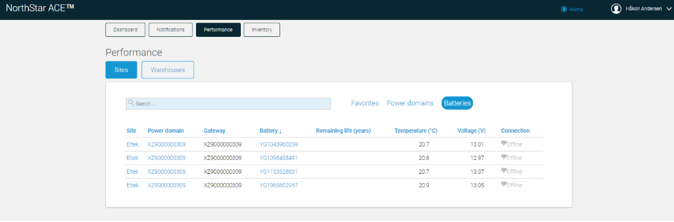

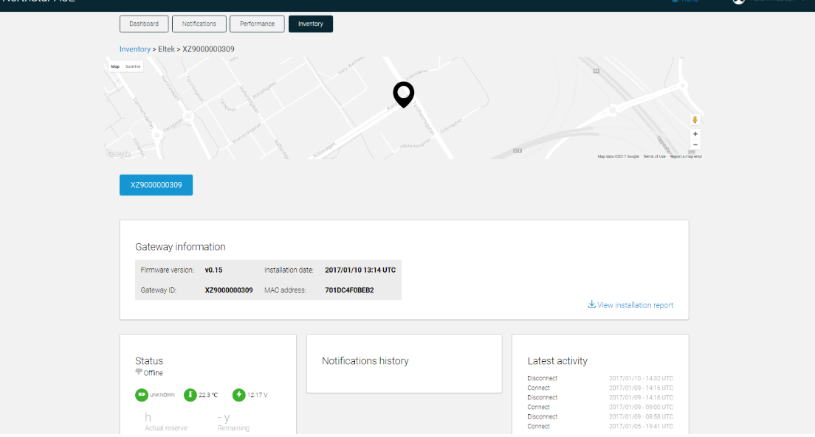

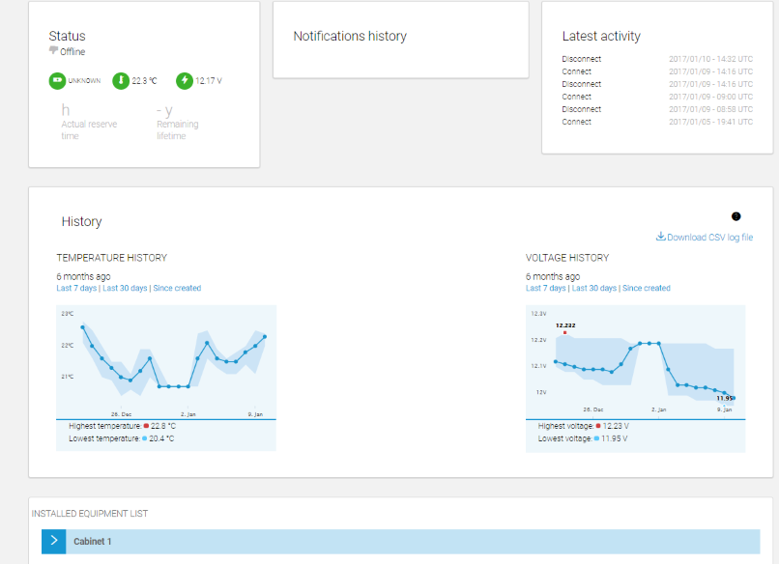

Configurable dashboard example iDean:

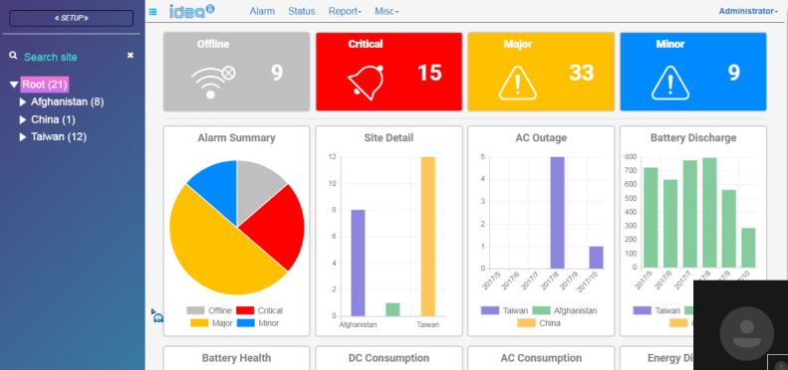

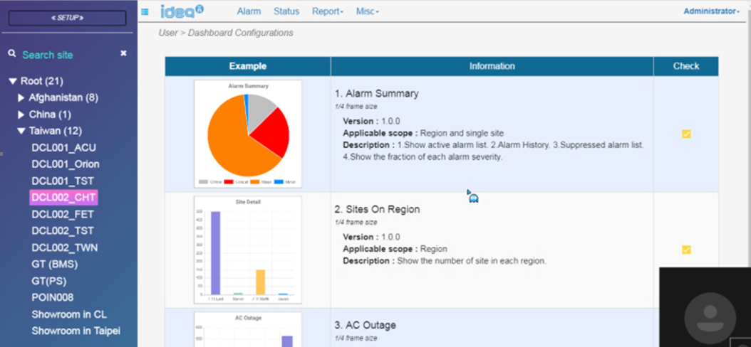

Inala ( old style UI, good features/information )
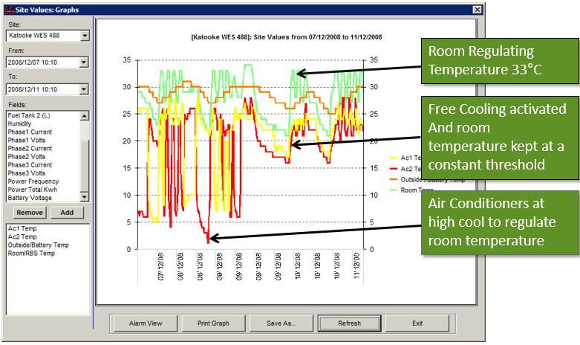

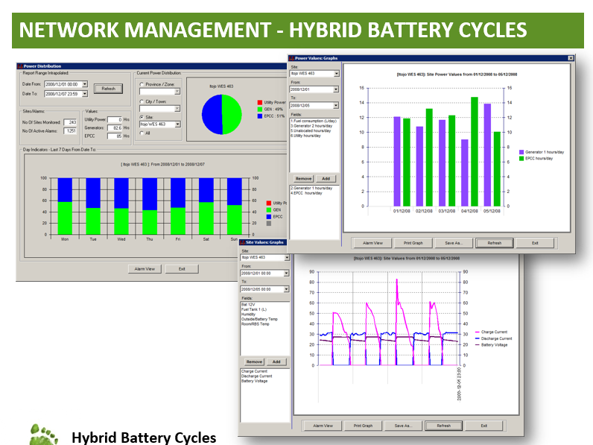

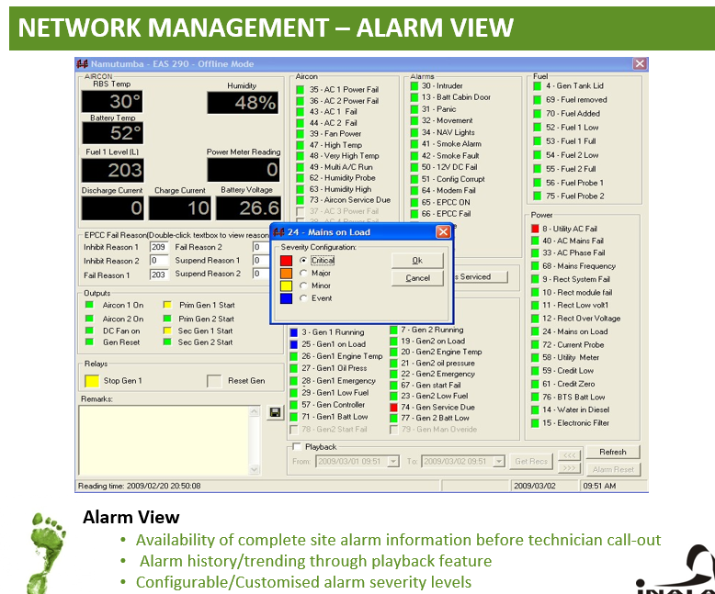

NetAct example of internal System Monitoring
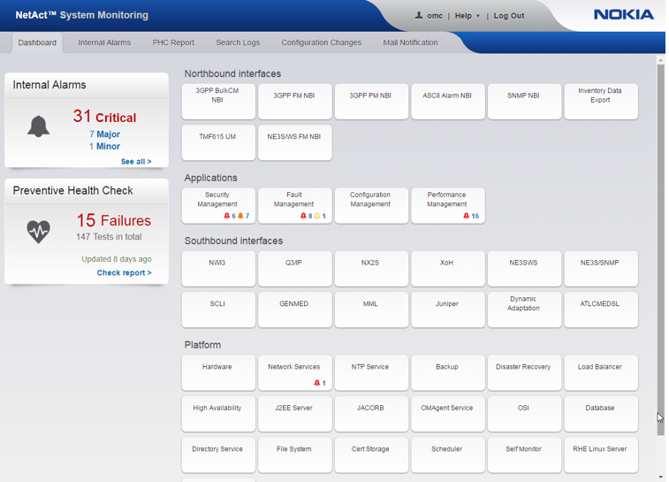

Vertiv / Emmerson
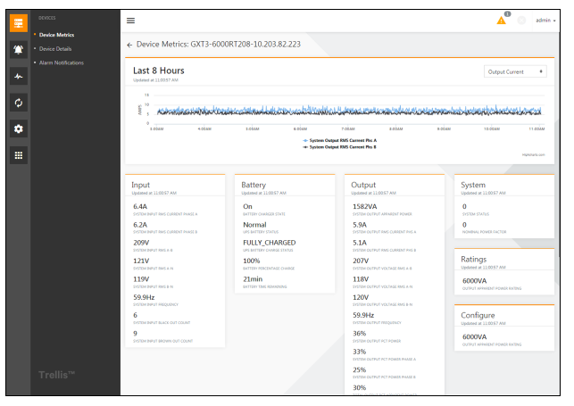

Huawei OLAP reporting ( HTML5 OLAP control would be nice to have )

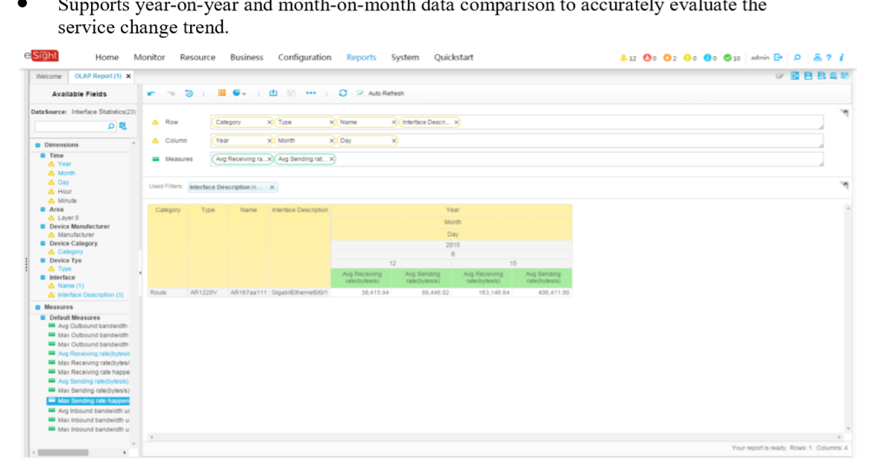

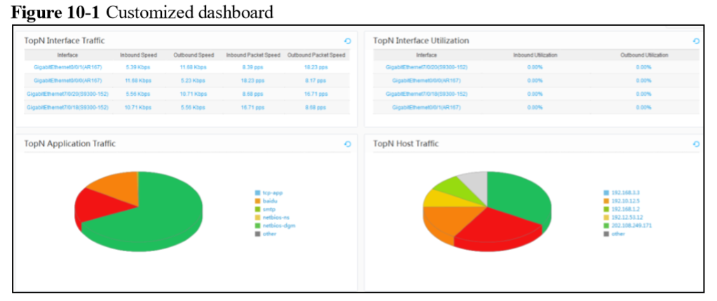

Example of extended Dashboard item in existing MSM (needs correct colors 😊)
